5" Telescope Mount
- Preliminaries
  - Using the mounting brackets from the original mount
  - Will use hand knobs with a worm gear system for moving the telescope manually
    - Motorization will happen later – if at all
  - All parts are to be printed.
- Overview drawing:
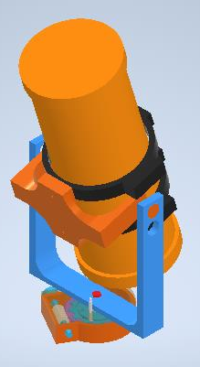
- Fork Component
  - File location: C:\git\CAD-Development\robSteele\ShapeWays\TelescopeProjects\TelescopeMountNov2020
  - File Name: fork.ipt
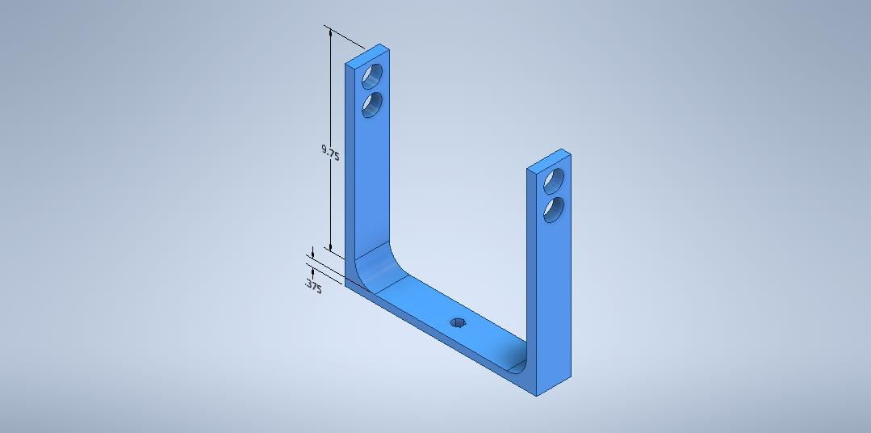
  - 1/2" thick.
  - 1/2" hex hole for connecting to the drive system.
  - 1" + print gap hole for the mount connecting arms.
- Connector to Tube
  - File Location: C:\git\CAD-Development\robSteele\ShapeWays\TelescopeProjects\TelescopeMountNov2020
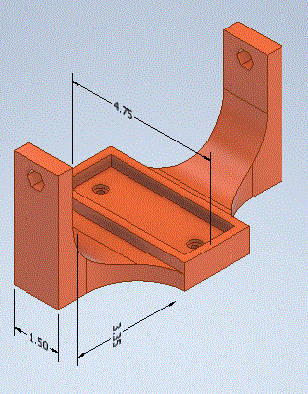
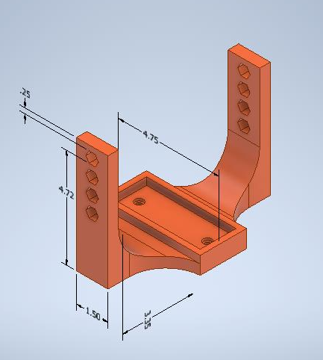
  - File Name: connectorToTubeBrackeCradle.ipt
  - Telescope bracket connections made to the base of the connector unit.
  - 1/2" hex holes for connecting to the drive system.
    - One side connects to the drive, the other side is simply for supporting the tube.
  - Intent is that the telescope tube and go from an altitude of 0° to 90°.
  - The hex size is 0.500" but for clearance for printing and getting parts slotted through the hole the dimension printed for the hex hold is 0.510.
- Celestron Tube Bracket
  - File Location: C:\git\CAD-Development\robSteele\ShapeWays\TelescopeProjects\TelescopeMount
  - File Name: celestronTubeBracket.ipt
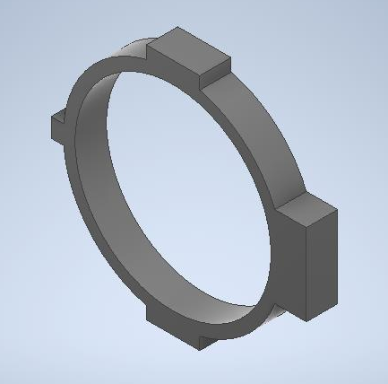
  - These are the ones from the original telescope mount.
- Telescope Tube
  - File Location: C:\git\CAD-Development\robSteele\ShapeWays\TelescopeProjects\TelescopeMount
  - File Name: telescopeTube.ipt

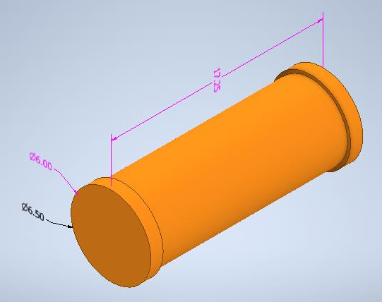
  - 5" Celestron telescope optical assembly
  - This model doesn't show the finder nor the eyepiece.
- Gear Lock with Bolt and Bolt Channels
  - File Location: C:\git\CAD-Development\robSteele\ShapeWays\TelescopeProjects\TelescopeMountNov2020
  - File Name: forkBaseWithWormGearAndLock.iam
  - This assembly has the worm gear, locking mechanism, and hand crank for moving the telescope in azimuth.
  - This is the key to the mount and has lots of different components that we be detailed.
  - The overall unit looks like:
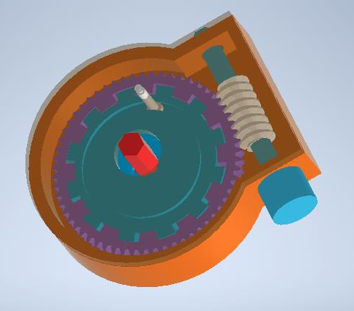
    - The worm gear ratio that I am using is 60:1.
      - File Location:
        - C:\git\CAD-Development\robSteele\ShapeWays\TelescopeProjects\TelescopeMount\forkMountForDecTripV01\Design Accelerator
      - File Name: Worm Gears5.iam
      - This means each rotation of the hand crank will result in a motion of 6°.
      - The gear was modified to have the splines cut in it for the brake. The worm was modified to have a 3/8" hex hole cut through the middle of the worm gear for drinving.
      - My current design calls for driving this by hand. If could of course be modified to use a motor in the future.
      - Photo:
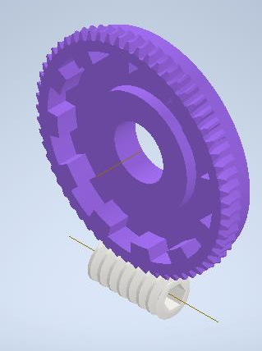
    - The locking mechanism:
      - Uses 12 splines, which means that the telescope can be portioned to an accuracy of 30°, which provides a pointing accuracy of ±15°.
      - There is a grove in the back side for attaching a shoulder bolt. The should bolt is used to lift the locking mechanism away from the worm gear, allowing it to move independently of the worm for position.
        - When released there needs to be a spring to assist with pushing it back into the mating splines for locking.
      - Front side of gear lock:
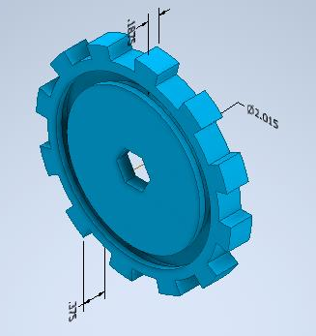
        - Rear side of gear lock:
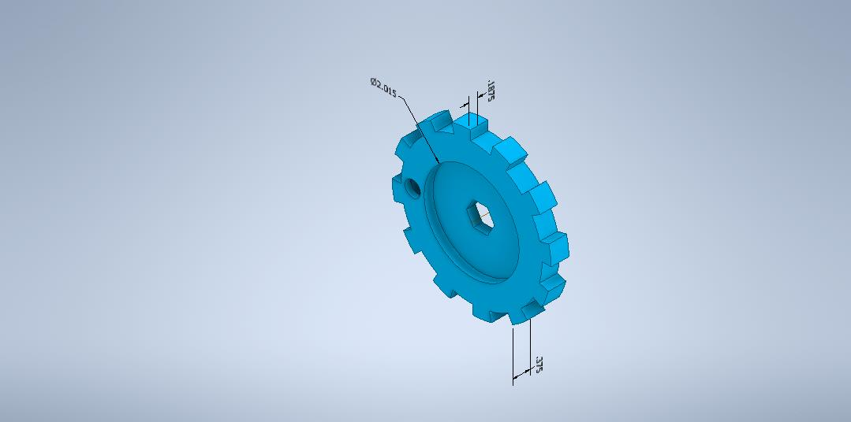
          - The rear side has a hole to allow for inserting the shoulder bolts.
        - The spacing for the spline teeth are controllred via parameters in the Autodesk Inventor files. Here is the schematic showing the spacing of the spline teeth:
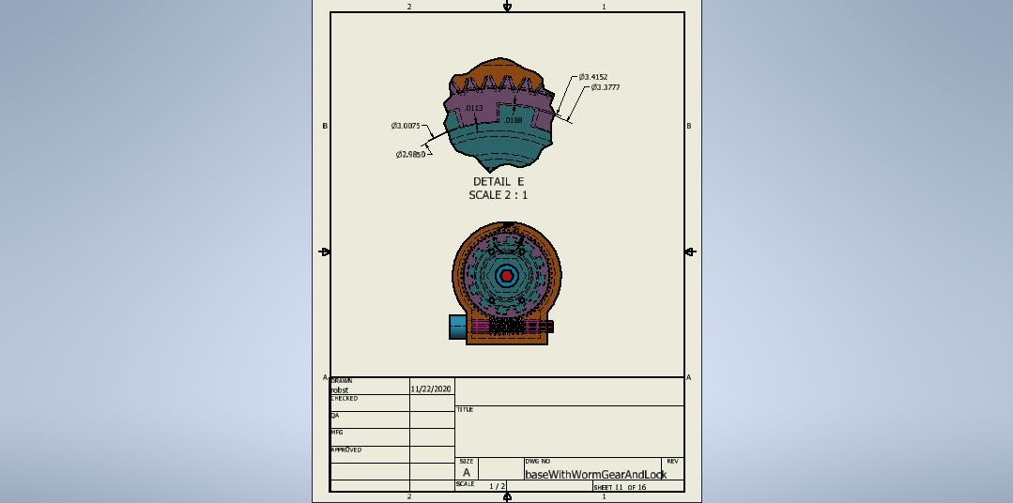
    - Shoulder bolt
      - McMaster-Carr shoulder bolt. The bolts currently selected have the same head dimensions. The sizes available are 1, 1 1/8, 1 1/4, 1 1/2, 1 3/4, and 2. A picture of the bolt looks like:
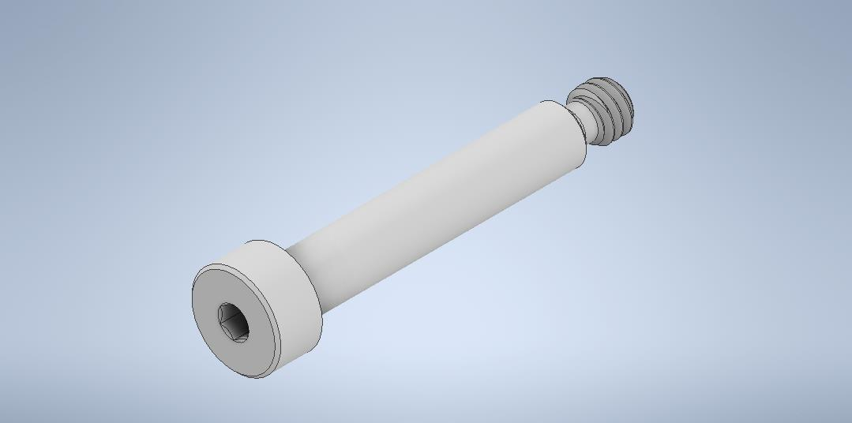
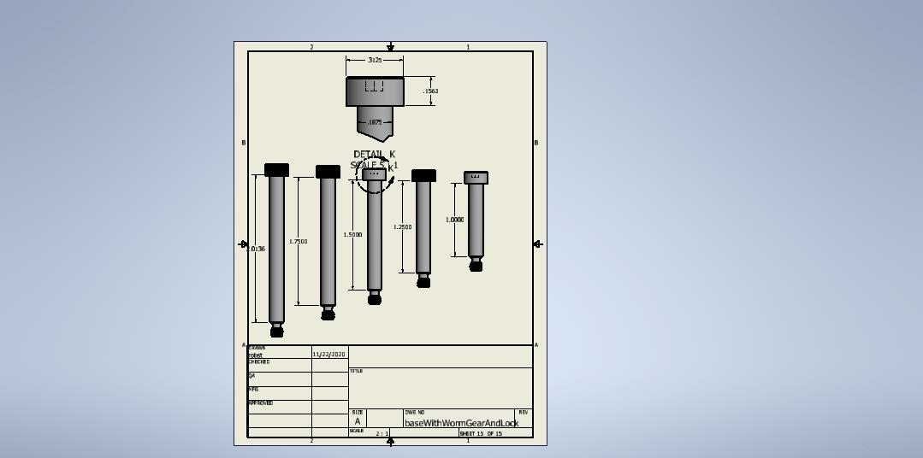
      - Schematic of 1 1/2 inch shoulder bolt:
      - Schematic showing channel for the gear lock:
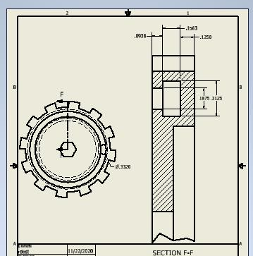
      - Schematic showing the placement of the screw in the gear lock housing:
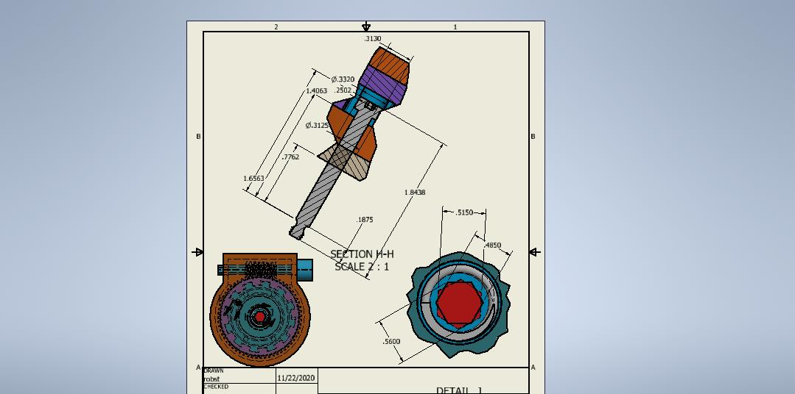
      - xxx
    - Base for gate lock
    - Cover plate for gear lock box:
      - File Location: C:\git\CAD-Development\robSteele\ShapeWays\TelescopeProjects\TelescopeMountNov2020
      - File Name: baseSupportCover.ipt
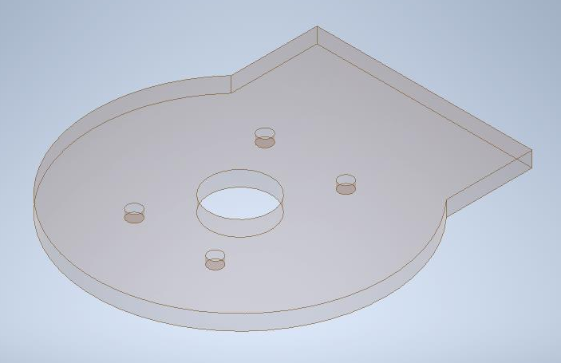
TODO

- Spring for gear lock
  - I have tentitively identified from McMaster-Carr part number 9657K512. The model schematic for that part is:
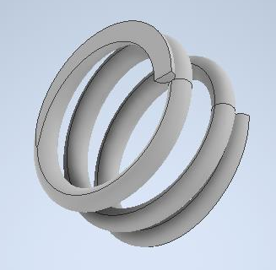
- Design a mechanism for lifting the lock away from worm gear such that the spring will push it back when the lifting mechanism is released.
- Looking into adding additional height to the fork.
- Add at least one, if not two holes, to the connectorToTelescope, to allow for multiple mouting options.
- Need to get gear lock attached to the altitude control for the telescope mount.
- ...

